# 

# **Department of Computer Science and Engineering Islamic University of Technology (IUT)** A subsidiary organ of OIC

# **Laboratory Report**

# CSE 4412: Data Communication and Networking Lab

## 

## **Name:** Tahsin Islam **Student ID:** 210042137 **Section:** SWE **Semester:** Summer (4th) **Academic Year:** 2022-2023

**Date of Submission:** 21/02/2023

### **Title:** Configuring and Verifying of RIP and OSPF in a network topology.

### **Objective**:

1. Describe the concept of dynamic routing.
2. Explain disadvantages of RIPv1 and improvement in RIPv2.
3. Configure Routing Information Protocol (RIP) in a network topology following given specifications.
4. Describe the concept of OSPF and related terminologies.
5. Explain the advantages of OSPF over RIP.
6. Configure OSPF in a network topology following the given specifications.

### 

### **Devices/ software Used**:

* + - 1. Laptop
      2. Cisco Packet Tracer

### **Theory:**

*(Explain in brief the listed keywords)*

1. **Routing Information Protocol (RIP)**

**Ans:** RIP is one of the oldest dynamic routing protocols used in computer networks. It's designed to allow routers to exchange routing information periodically within a network. RIP uses hop count as its metric to determine the best route to a destination network. Despite being obsolete in many modern network environments due to its limitations, RIP is still taught and understood because it provides a foundational understanding of dynamic routing protocols.

1. **Forwarding Table used in RIP**

**Ans:** In RIP, routers maintain a routing table, also known as a forwarding table, which contains information about reachable destinations in the network. This table includes entries for various networks along with associated metrics (typically hop counts in RIP) that indicate the cost of reaching those destinations. The router consults this table to determine the next hop for forwarding packets towards their destination.

1. **Hop Count as cost**

**Ans:** In RIP, the metric used to evaluate the "cost" of reaching a destination network is the hop count. Hop count refers to the number of routers (or hops) that a packet must traverse to reach the destination network. Each hop between routers typically incurs a certain amount of delay and resource consumption, so minimizing hop count generally leads to more efficient routing paths.

1. **Timers in RIP**

**Ans:** RIP employs several timers to manage the exchange of routing information and to detect network topology changes. The key timers in RIP include:

* Update Timer: This timer determines how frequently routers send routing table updates to their neighbors. In RIP, updates are sent every 30 seconds by default.
* Invalid Timer: When a router stops receiving updates about a particular route, it starts the invalid timer. If no updates are received for a route within a certain period (typically three times the update timer), the route is considered invalid.
* Hold-down Timer: After marking a route as invalid, the router starts the hold-down timer. During this time, the router suppresses any route updates received for the invalid route, preventing potentially incorrect information from being propagated.
* Flush Timer: Once the hold-down timer expires, indicating that the route is likely stable again, the router starts the flush timer. After the flush timer expires, the route is removed from the routing table if no updates confirming the route's validity are received.

### **Diagram of the experiment**

**Task #01:**

### **Working Procedure:**

**Step 1: Configuring Routers**

At first I changed the host name of the routers. Here I am providing codes for R1, then I configured the router. The process for router-2 is similar. To do this, I have used the following commands:

|  |
| --- |
| En  Config t  Hostname R1  Serial 0/1/0  Ip address 172.137.0.2 255.255.255.224  No shut  exit  Int gig 0/0  Ip address 172.140.0.1 255.255.255.192  No shut  Exit  Int gig 0/1  Ip address 172.140.0.150 255.255.255.192  No shut  Exit  Router rip  Network 172.137.0.0  Network 172.140.0.0  Exit |

Here are the screenshots:

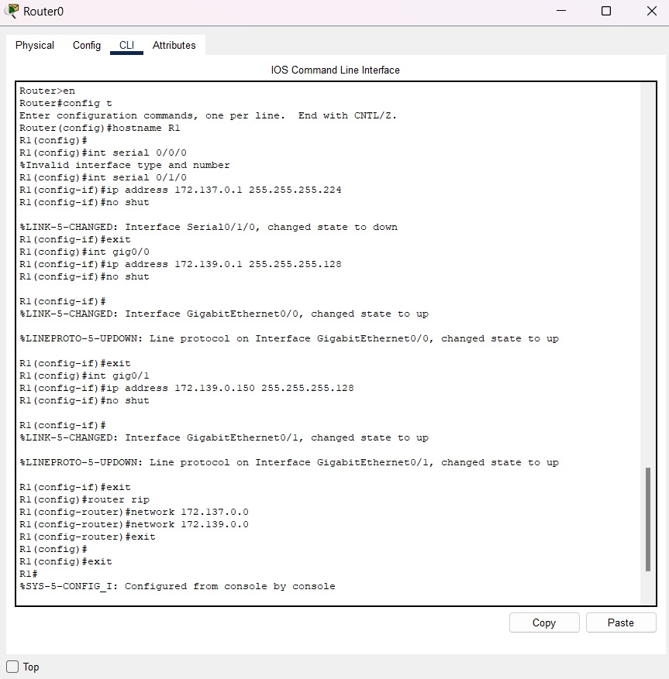

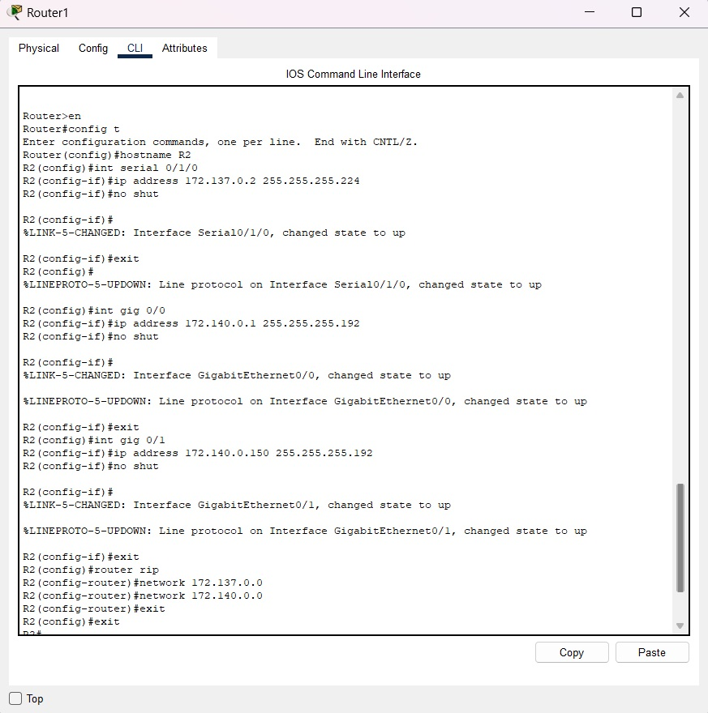

**Step 1: Setting Up IPs**

As my ID’s last 2 digits are 37, IP addresses are:

Here are the screenshots:

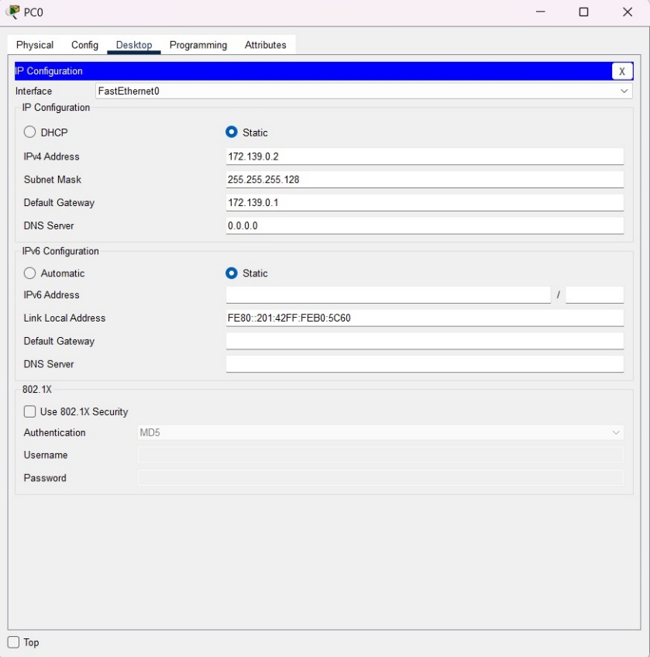

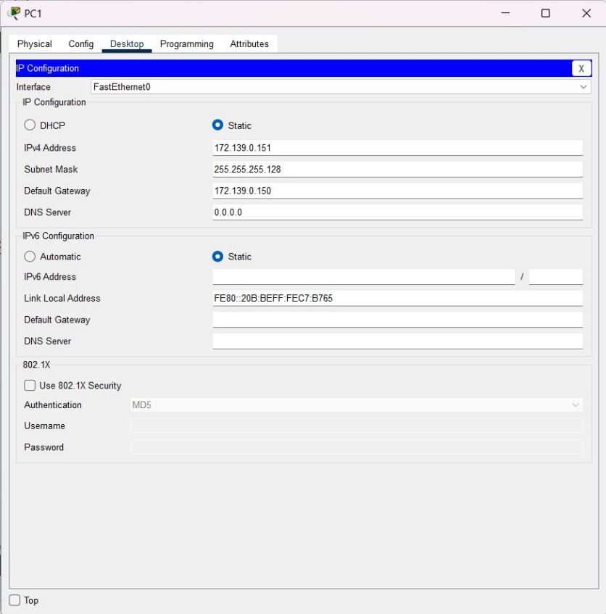

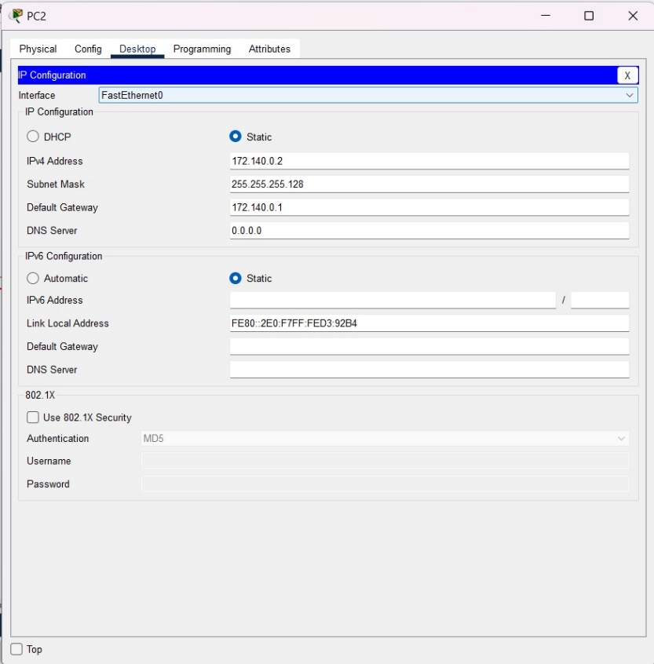

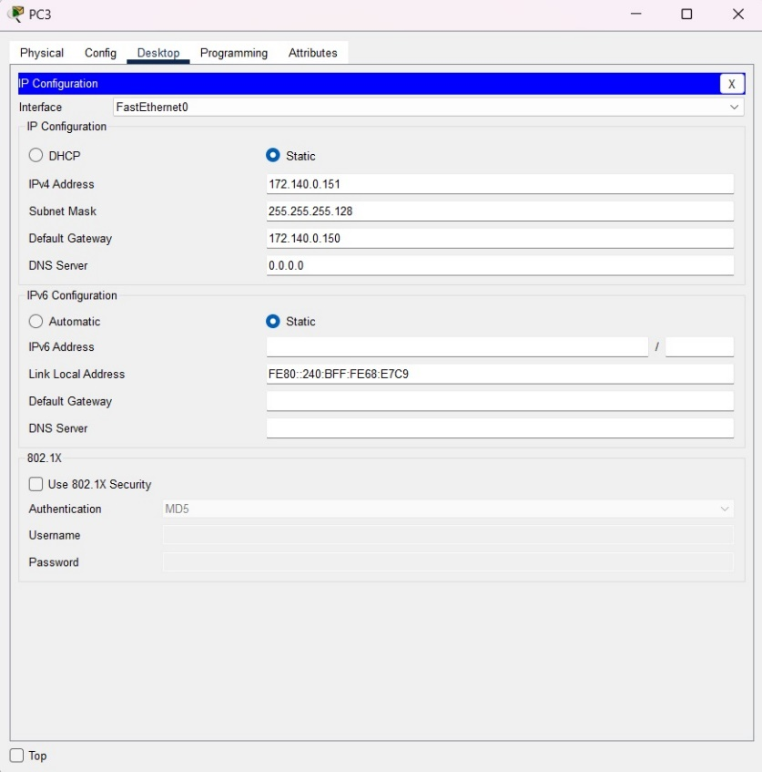

**Step 3: Using the ping command from the Terminal**

Here are the screenshot of sending packets to another PC:

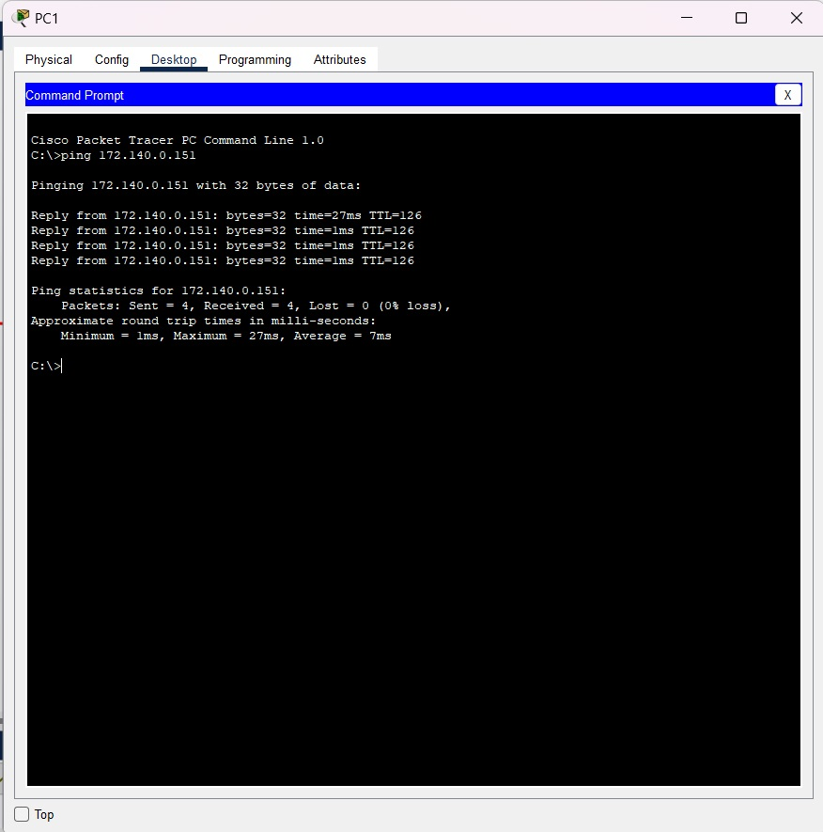

### **Challenges (if any):**

No challenges faced.